A study of the concepts of Digital Marketing Techniques

Rao Randhir Singh
(Roll No: 13125042)
Course No.: MBA699
Semester: I Semester, 2014-15

Supervised by: Dr Shashi Shekhar Mishra

Submitted On: 12th November 2014



Indian Institute of Technology Kanpur
Department of Industrial and Management Engineering

Acknowledgements

I am extremely grateful to Dr Shashi Shekhar Mishra , whose guidance as my project supervisor has made this study possible. His knowledge, experience, disciplined approach, constructive criticism and valuable suggestions have been a source of inspiration to me. I would like to express my sincere reverence to all faculty members at IITK for giving insights of the concepts, which are a prefect blend of theoretical understandings and practical aspects at regular intervals. Finally, I would take this opportunity to express my gratitude to Dr Jayanta Chatterjee for providing me with his valuable insights and knowledge on this topic.

Signature
(Rao Randhir Singh)

Self Certification

I, Rao Randhir Singh, Roll number 13125042 submit the report on my Special Study/Project entitled ‘A study of the concepts of Digital marketing Techniques:’, carried out for the Course Number MBA 699 during the I Semester 2014-15, in the Department of Industrial and Management Engineering. I confirm that the topic was approved by my supervisor at the beginning of the semester.

This work contains no material which has been submitted as a part of, or in full, for any other project/review/report.

To the best of my knowledge and belief, this work does not contain any material previously published or written by another person or me, except where due reference has been made in the text. I certify that plagiarism of any kind has not been done by me in producing this report.

The work is based on the research done by me after joining the MBA programme in the Department of Industrial and Management Engineering, IIT Kanpur.

Signature of the Student

Name of the Student: Rao Randhir Singh

Roll Number: 13125042

Place and Date : Kanpur, Uttar Pradesh, India

Table of Content

Page No.
1. Introduction ....................................................................................................................... 1
1.1 Brief background of Digital Marketing Techniques

2. Literature Review ............................................................................................................ 2

3. Method Used.......................................................................................................................3
3.1 Website Design
3.2 Search Engine Optimization: Organic Search
3.3 Search Engine Marketing: Google Adword campaign
3.4 Social Media Marketing: Creation of facebook page for the website
3.5 Analytics: Google Analytics to measure performance

4. Results ............................................................................................................................ 16
4.1 Analysis
4.2 Interpretation of results

5. Limitations

6. Conclusions ................................................................................................................... 18
6.1 Conclusions
6.2 Scope for further study

1. Introduction

  - Brief background of Digital Marketing Techniques

Digital Marketing can be defined as a technique to promote a product, service or brand or all of these through the use of electronic media. With the advent of internet, it has become an important and cheap medium to target a wide array of customers. Thus, Digital marketing is going to become a huge field in the overall study of Marketing! It involves building a website that could be used to market products, services or brands. It is very important that the website that is built for this purpose is very good so that it is able to compete with its competitors well. With a very good website, I mean to say that the website should be such that it attracts more customers, its content should be such that it is able to show in top results of any search engine like Google or Bing. These concepts are briefly summarized under the following heads:

Search Engine Optimization and Search Marketing: Search Engine Optimization is the beginning step in Digital Marketing. Just building a website does not conclude your job. It is of no use if whatever you have built for business purpose, is not reachable to a large customer base. Search Engine Optimization is a technique by which the contents of a website are optimized to put it on a higher position in search engines’ search results. This is also termed as Search Marketing if you t do it through the use of Ad words and other paid search optimization techniques. Thus, it is very important that the website be such that it appears on the top of a search result in case a user tries to find out for something that is relevant to the business that is represented through the website. A search engine involves complex methods to determine the rank of a website from among a million of similar web pages present on WWW. It is based on parameters like content, description, unambiguity of URL used etc. Optimization involves developing a website with these best practices in mind to show the website on top in search results. Search Marketing involves other paid techniques to promote the website. We will discuss about these concepts in details in the subsequent sections.

Social Media Marketing: Social Media Marketing is another facet of Digital Marketing. It uses social media channels like Facebook, Twitter and LinkedIn to market a website. It is a cheap and very good medium to reach a large customer base and make them aware of what you have to offer. It usually goes hand in hand with the SEO and SEM techniques mentioned above. SMM also offers paid promotion techniques to boost a website. It also gives you cushion to handle positive as well as negative comments and protects your businesses’ image from getting tarnished in case someone is creating a negative Buzz about it.

Analytics: Analytics enables you to monitor your website’s performance as to how it is performing in the search results, how people are exploring it and is it earning any business or not. Platforms like Google Analytics allow you to include code in your website’s source code and track its functioning. Parameters like ‘Bounce Rate’ allows you to monitor as to what a user is exactly doing on your website, is he doing something relevant or not etc. Analytics results help you to further optimize/fine tune your website to fetch better results. It too, usually goes hand in hand with the other aspects of Digital marketing.

In this study, I have done an experiment by creating a website and applying the techniques of Digital Marketing on it to achieve a higher rank in Google search results for a set of keywords typed. Before this, I attempted to learn the various theoretical aspects of the same by doing an extensive Literature Review which I discuss in the next section.

2. Literature Review

A detailed Literature Review was carried out to delve deep into the theoretical aspects of Digital Marketing Techniques. I used a number of papers and online materials to understand the concepts of the following:

How does a search engine work: How does a Search Engine assign rank to a page? What is its high level architecture? How does a page rank algorithm work? What is indexing? For getting a good understanding of these concepts I referred the below article:
Reference: http://scholarworks.gvsu.edu/cgi/viewcontent.cgi?article=1153&context=cistechlib

What are the best practices of Search Engine Optimization: How is the source code of a website optimized to achieve higher ranks in organic search results? What kind of titles should be added, what kind of descriptions to use, how to optimize the content, what is the best structure of URL to use, how to create a good landing page etc.? For a good understanding of these concepts, I referred the below article:
Reference: http://static.googleusercontent.com/media/www.google.com/en//webmasters/docs/search-engine-optimization-starter-guide.pdf

How to create and manage adword campaigns: How are Adwords created? What are the various types of Adword campaigns? What is the basic fundamental of the working of AdWords? How is bidding done, how to show an ad on the top of google searches, how to achieve a good quality score, how to manage keywords, conducting keyword research, various types of keyword matches and their significance in achieving better results, concepts of Impressions, Pay per click, click through rate etc.? For a good understanding of these concepts, I referred the articles on the below link:
Reference: https://www.google.com/partners/?hl=en-US#p_adwordscertification

Other References: http://scholarworks.gvsu.edu/cgi/viewcontent.cgi?article=1153&context=cistechlib
https://support.google.com/webmasters/answer/35624?rd=1
http://blog.hubspot.com/marketing/how-to-do-keyword-research-ht
http://www.studymode.com/essays/Literature-Review-On-Increasing-Website-Traffic-1017368.html

3. Method

3.1 Website Design

For the purpose of experimenting, I designed a website with the name, ‘Online Test’. It comprises of three pages with very basic features and functionalities. The screenshots of pages of the website are shown below:

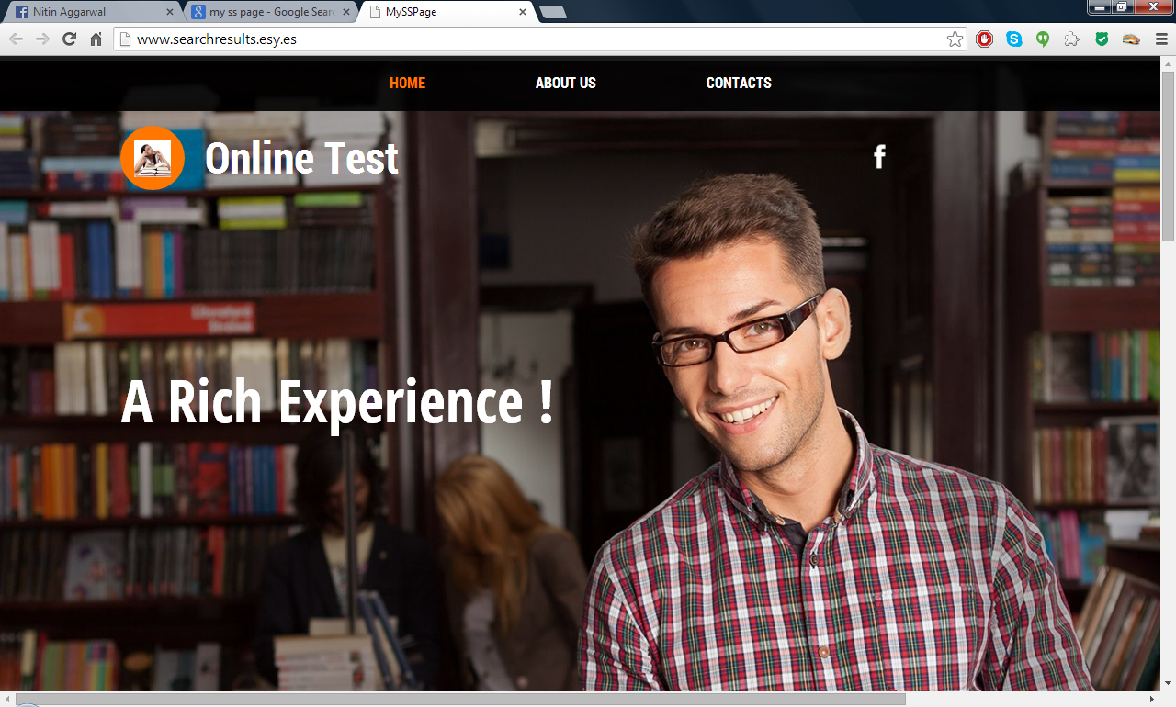
Figure 1: The HOME page of Online Test

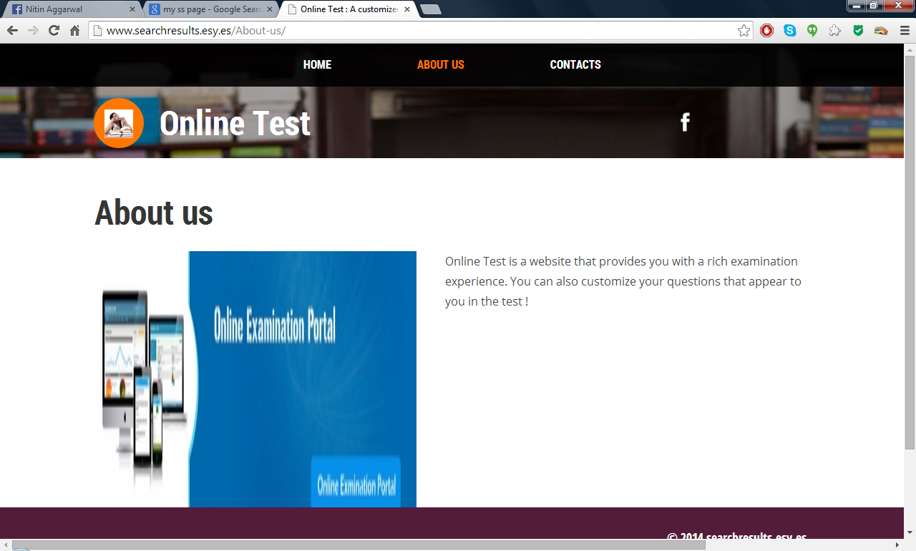
Figure 2: The ABOUT US page of Online Test

3.2 Search Engine Optimization: Organic Search

The source code of the website designed for the purpose was optimized along the following guidelines of best practices:

Indicate page titles by using title tags: Page title contents are displayed in search results. This can help users recognize if the page is likely to be relevant to their search. The title for your homepage can list the name of your website/business and could include other bits of information like the physical location of the business or maybe a few of its main focuses or offerings. Figure 3 and the HTML code snippet below it depict the relevant result and code match.

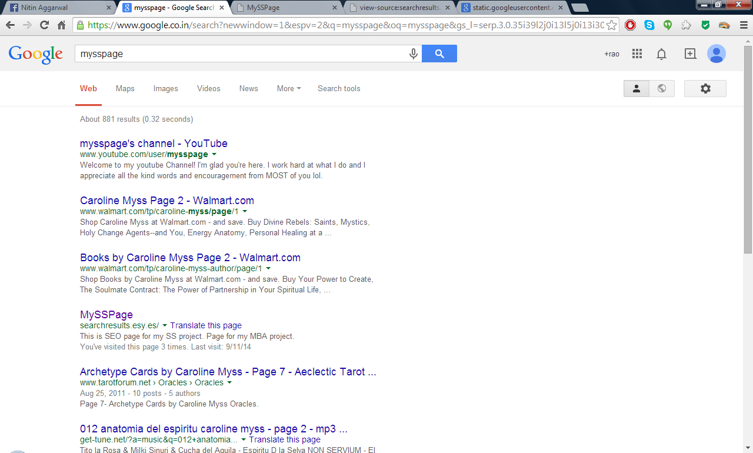

Figure 3: Site featuring in Google's organic search results. Title shown as MYSSPAGE

<!DOCTYPE html>
<html lang="en">
<head>
<meta http-equiv="content-type" content="text/html; charset=utf-8" />
<title>My SS Page</title>
<base href="{{base_url}}" />
<meta name="viewport" content="width=1000" />

Summaries can be defined for each page: A page's description meta tag gives Google and other search
engines a summary of what the page is about. Description meta tags are important because Google might use them as snippets for your pages. Avoid writing description meta tags that has no relation with the page. Also, use unique description for each page. Words in the snippet are bolded when they appear in the user's query. This gives the user clues about whether the content on the page matches with what he or she is looking for. Write a description that would both inform and interest users if they saw your description meta tag as a snippet in a search result. Use unique descriptions for each page. The code snippet below gives the two separate descriptions for the Home and About Us pages respectively.

<!DOCTYPE html>
<html lang="en">
<head>
<meta http-equiv="content-type" content="text/html; charset=utf-8" />
<title>My SS Page</title>
<base href="{{base_url}}" />
<meta name="viewport" content="width=1000" />
<meta name="description" content="This is SEO page for my SS project.
Page for my MBA project" />

<!DOCTYPE html>
<html lang="en">
<head>
<meta http-equiv="content-type" content="text/html; charset=utf-8" />
<title>Online Test : A customized online testing experience</title>
<base href="{{base_url}}" />
<meta name="viewport" content="width=1000" />
<meta name="description" content="Online Test is a website that provides you with a rich examination experience. You can also customize your questions that appear to you in the test !" />

Improve the structure of your URLs: Simple-to-understand URLs will convey content information easily. Creating descriptive categories and filenames for the documents on your website can not only help you keep your site better organized, but it could also lead to better crawling of your documents by search engines. Also, it can create easier, "friendlier" URLs for those that want to link to your content. Visitors may be intimidated by extremely long and cryptic URLs that contain few recognizable words. URLs like (1) can be confusing and unfriendly. Users would have a hard time reciting the URL from memory or creating a link to it. Also, users may believe that a portion of the URL is unnecessary, especially if the URL shows many unrecognizable parameters. They might leave off a part, breaking the link. Some users might link to your page using the URL of that page as the anchor text. If your URL contains relevant words, this provides users and search engines with more information about the page than an ID or oddly named parameter would. In my example, I am using the URL ‘MYSSPAGE’ throughout to maintain consistency.

https://www.facebook.com/MySSPage

MySSPage
searchresults.esy.es/
Translate this page
This is SEO page for my SS project. Page for my MBA project.
You've visited this page many times. Last visit: 10/11/14

Searching directly with MYSSPAGE on Google thus, fetches me the result for my website (refer figure 3 above).

Make your site easier to navigate: Allow for the possibility of a part of the
URL being removed.

The URL: http://searchresults.esy.es/Home/ should tale you to the home page and the URL: http://searchresults.esy.es/About-us/ should take you the About Us page of the website. Also, the URL: http://searchresults.esy.es/ should take you to the default page which is the HOME page for my website. This is happening with ease here!

Offer quality content and services: Users know good content when they see it and will likely want to direct other users to it. This could be through blog posts, social media services, email, forums, or other means. Organic or word-of-mouth buzz is what helps build your site's reputation with both users and Google, and it rarely comes without quality content. For my purpose, I have given the link of my facebook page ‘Online Test’ where I am spreading about the website’s content and features. It is useful to create fresh, unique content and stay organized around the topic. This increases the probability of showing up more on the google search results.

Make use of exclusive keywords that you expect your users to write: Writing the expected keywords and too, different keywords for different pages of your website, increases the probability of showing up more. This however, shall be optimized regularly and based on the ongoing results.

<!DOCTYPE html>
<html lang="en">
<head>
<meta http-equiv="content-type" content="text/html; charset=utf-8" />
<title>My SS Page</title>
<base href="{{base_url}}" />
<meta name="viewport" content="width=1000" />
<meta name="description" content="This is SEO page for my SS project.
Page for my MBA project" />
<meta name="keywords" content="My SS page,SS project,My SS project,mba projects,2013-15 SS,MBA projects,SEO page for my MBA project" />

<html lang="en">
<head>
<meta http-equiv="content-type" content="text/html; charset=utf-8" />
<title>Online Test : A customized online testing experience</title>
<base href="{{base_url}}" />
<meta name="viewport" content="width=1000" />
<meta name="description" content="Online Test is a website that provides you with a rich examination experience. You can also customize your questions that appear to you in the test !" />
<meta name="keywords" content="A customized online testing experience,Online Test,A customized online testing experience,Online examination" />

The code snippet shown above shows how different set of keywords have been used for the ‘HOME’ and ‘ABOUT US’ pages respectively.

3.3 Search Engine Marketing: Google Adword campaign

Google AdWords is an online advertising service that places advertising copy at the top, bottom, or beside, the list of search results Google displays for a particular search query. The choice and placement of the ads is based in part on a proprietary determination of the relevance of the search query to the advertising copy. AdWords offers pay-per-click (PPC), that is, cost-per-click (CPC) advertising, cost-per-thousand-impressions or cost per mile (CPM) advertising, site-targeted advertising for text, banner, and rich-media ads, and remarketing. The AdWords program includes local, national, and international distribution. Google's text advertisements are short, consisting of one headline of 25 characters, two additional text lines of 35 characters each, and a display URL of 35 characters. Image ads can be one of several different Interactive Advertising Bureau (IAB) standard sizes.

Organizing the account: Organization gives your account a solid framework, making it easier to determine which of your ads, campaigns, and keywords are working, and which aren’t, so you can alter or add campaigns as necessary.
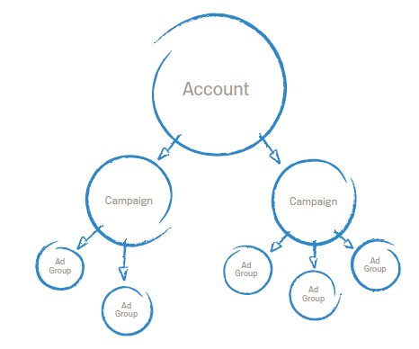
There are two main components to your AdWords account: campaigns and ad groups. An AdWords account can contain up to 25 campaigns; a campaign can have up to 100 ad groups; and ad groups caninclude hundreds of keywords. You can find all your campaigns, and their component ad groups, in the Campaign Management tab of your AdWords account. When it comes to giving your AdWords account a strong foundation – and making it easier to get the most out of AdWords – taking the following steps is key. To see which of your messages resonate with customers, write three or four ads at one time. Then check your clicks. The ads with the highest click-through rates (CTR) are your top performers. Once you know which of your ads work, you can rewrite poorly performing ads so they’re more in line with the good ones.
Ad consist of three parts :
- Headline
- Description
- URL

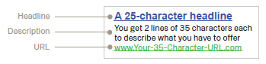

Quality Score-
It is an an estimate of the quality of your ads, keywords, and landing page. Higher quality ads can lead to lower prices and better ad positions. The components of Quality Score (expected click through rate, ad relevance, and landing page experience) are determined every time your keyword matches a customer's search.
Bounce Rate-
Represents percentage of visitors, who enter the site and “bounce”(leave the site) rather than continue viewing other pages on the same site. In my case, I am creating an event where if someone clicks on the facebook link of my page, he/she has done something there else he has contributed to the number of bounces.
Work done:
- Added relevant extensions (call extensions, site link extension, review extension) to each ad, resulting to increased impressions hence increased clicks.
- Added relevant keywords to each ad so that impressions and click rate increases.
- Removed repeated keywords.
- Added click to call feature for mobile users, to directly call for booking and queries, by adding mobile ads.
- Removed generic keywords as they increase impression by publishing the ad even on other categories because of broad match. This led to more bounce rate. So by removing the generic keywords, bounce rate decreased.
- Specifying more refined destination URL’s, so that clicking the ad redirects to required web page.
Implementation of all these factors led to low cost and higher CTR.
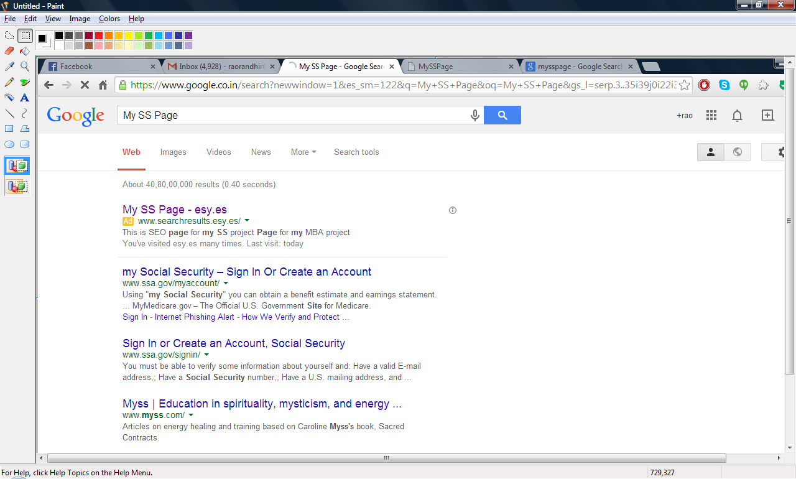
Figure 4: MY SS PAGE - esy.es; my ad showing on
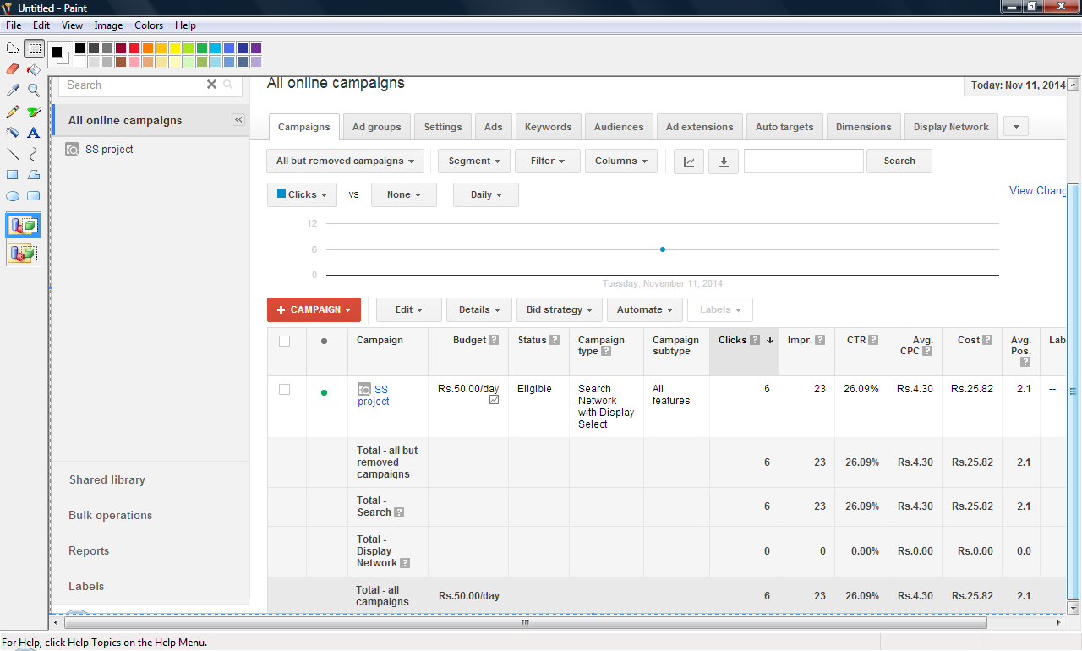
Figure 5: Ad campaign for my website: SS project

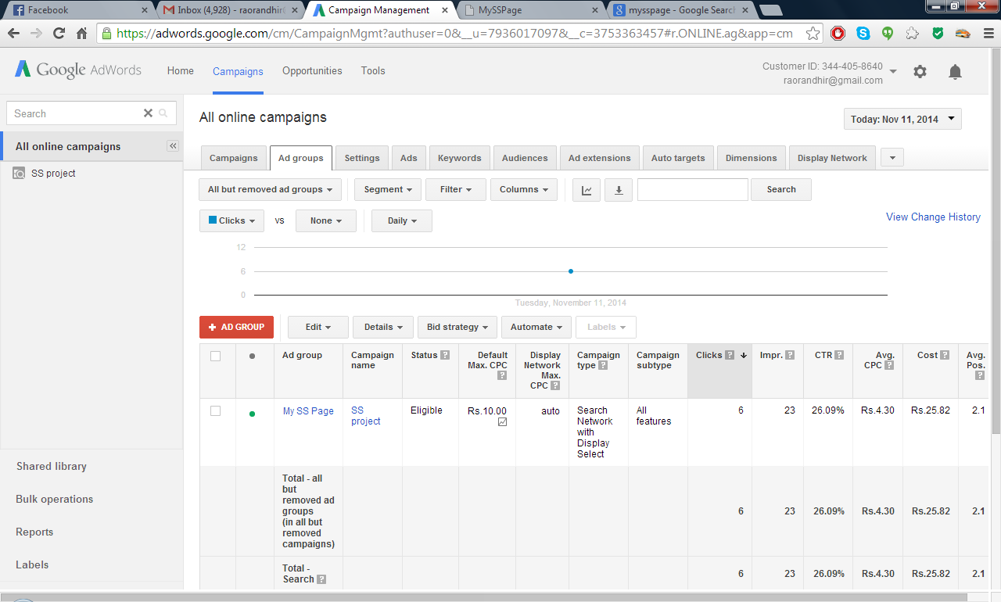
Figure 6: The Ad group of my campaign: My SS Page

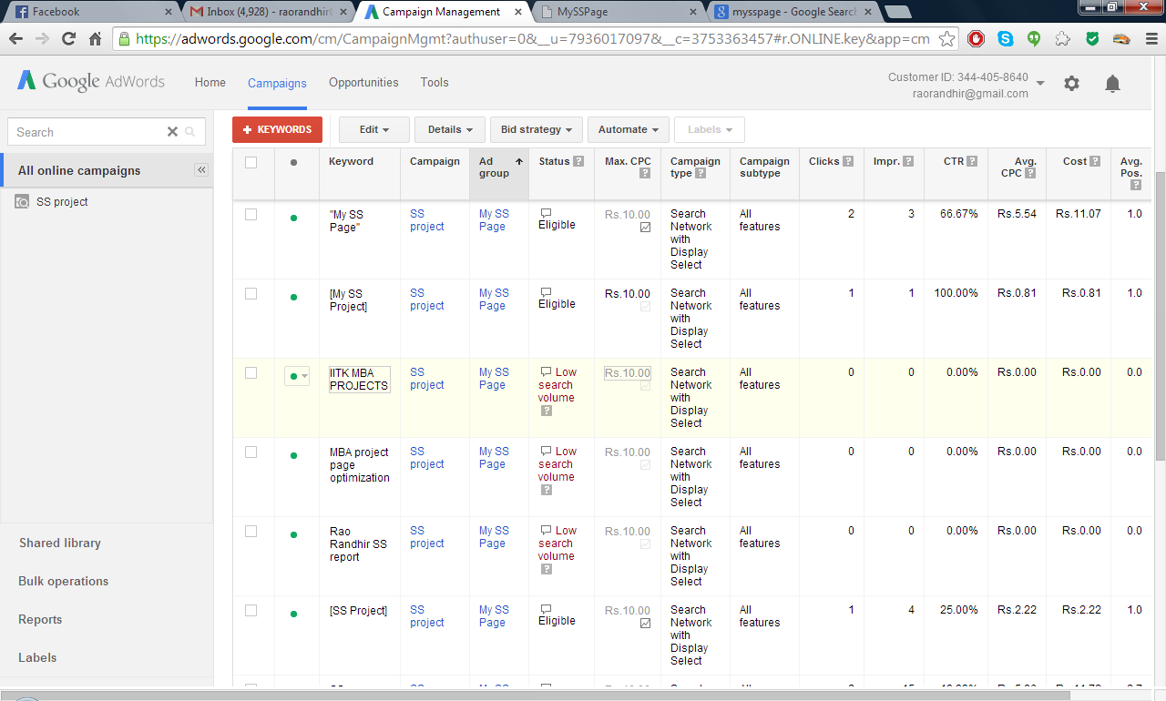
Figure 7: List of keywords for my ad campaign

Figure 7 on the previous page shows the list of keywords for my ad campaign. I have used different kind and type of keywords for this purpose here for learning their applications.

“MY SS PAGE” : It is a ‘Phrase Match’ keyword; a keyword setting that allows your ad to show only when someone's search includes the exact phrase of your keyword, or close variations of the exact phrase of your keyword, with additional words before or after. The phrase match keyword "bicycle bell" can cause your ad to show if someone searches for "bicycle bell," "buy bicycle bell," and "bicycle bell reviews." In this case if someone searches “MY SS” also, the ad will show up to him/her.

[My SS Project]: It is a ‘Exact Match’ keyword; a keyword setting that allows your ad to show only when someone searches for the exact phrase of your keyword or close variations of the exact phrase of your keyword. The exact match keyword "bicycle bell" can cause your ad to show only if someone searches for "bicycle bell" or close variations of "bicycle bell" exactly, with no other words. In this example, the ad will only show to one who types ‘My ss Project’.

SS page: It is a ‘Broad Match’ keyword. When you use broad match, your ads automatically run on relevant variations of your keywords, even if these terms aren't in your keyword lists. This helps you attract more visitors to your website, spend less time building keyword lists, and focus your spending on keywords that work. In this example, if someone types ‘SS’ or ‘SS page’ or ‘S page’, it is a high probability that the ad will show up to him/her.

Apart from these, Ad words involve choosing a region and display networks where your ads shall be displayed. In this case, I have chosen India as the region; the ads can show up anywhere in India and I have chosen the display networks as Search results as well as other display partners like You Tube. This enables the ad to show up to people searching on Google as well as Google’s partner sites, which is You Tube in our case.

Further to this, Ad Words enable you to choose negative key words for your campaign so that if someone searches through that keyword, your ad is not displayed to him/her for thaose keywords. In my example the negative keyword that I am using is: IIT Kanpur MTech project which is of broad match type.

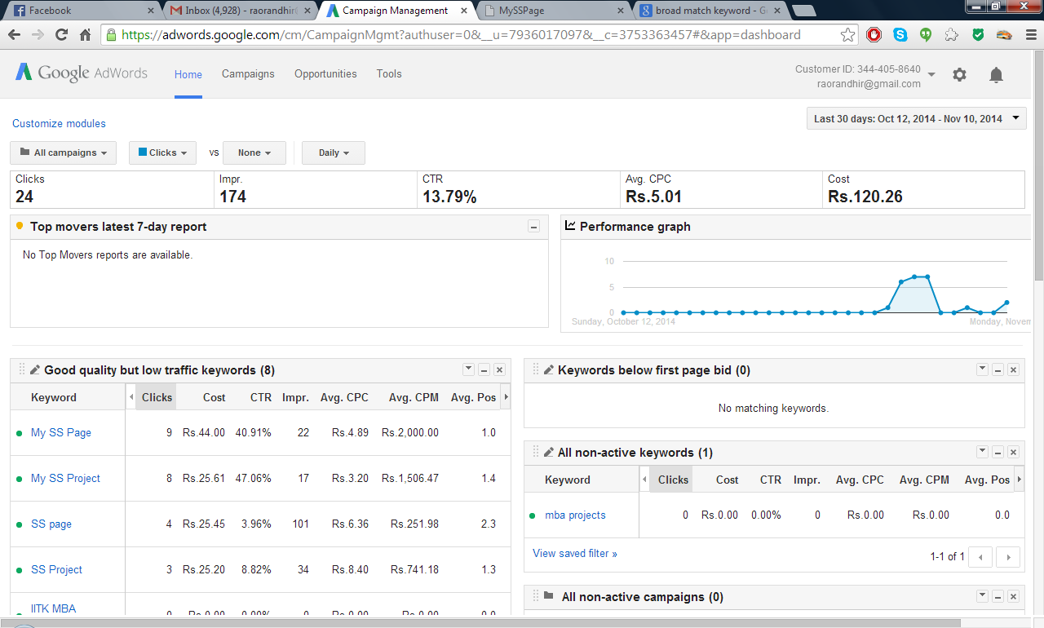
Figure 8: Summary of my ad campaign for last one month

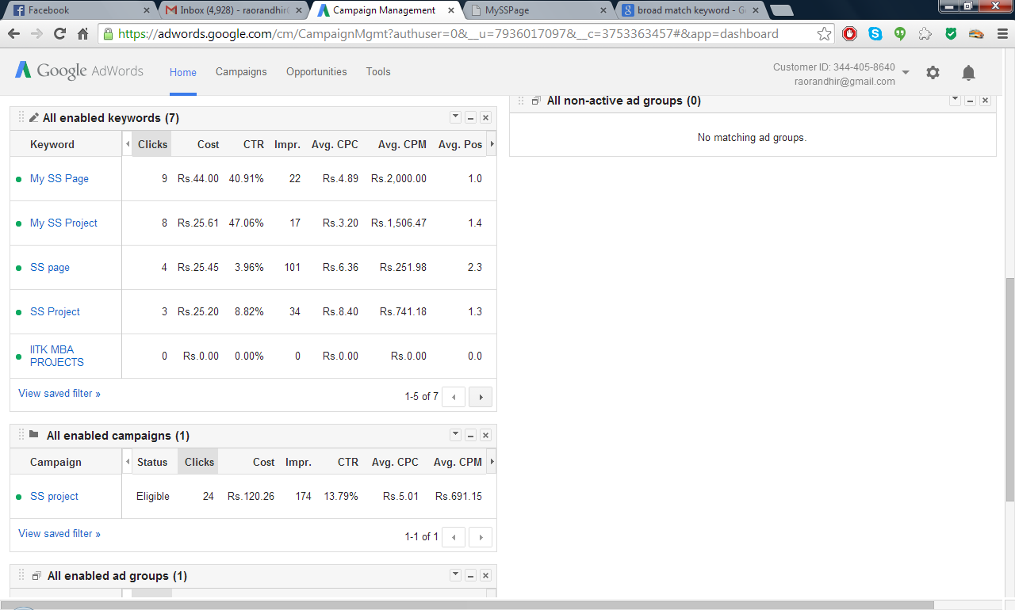
Figure 9: Summary of my ad campaign for last one month (contd)
Figure 8 and 9 on the previous page summarize the actual working of my ad campaign. Impression (Impr.) refers to the number of times the ad appeared to people all over India for various combinations of the keywords used. It is a measure of how much popularity did the campaign gain. CTR (Click through rate) determines how many times your ad was clicked. As per my settings, this is the campaign type that I have chosen. This incurs cost to me whenever someone clicks on the ad and the cost that is incurred is dependent on my Quality score.

3.4 Social Media Marketing: Creation of facebook page for the website

Users know good content when they see it and will likely want to direct other users to it. This could be through blog posts, social media services, email, forums, or other means. Organic or word-of-mouth buzz is what helps build your site's reputation with both users and Google, and it rarely comes without quality content. To ensure this, I have created a facebook page named ‘Online Test’ for my website and the link appears on all the pages of the website. This helps user gain more insight about the website. The page shares information about the website. Alternately, the facebook page contains the website’s link address and anyone who visits the page (friends or unanimous users), they can click the link to see the website. This helps achieving more website visits and also helps in the ‘Crawling’ that Google does when it ranks a page to be shown in its search results. Thus, it is very important to include social media forums to ensure good marketing of your offerings. The figure below shows the facebook page that I have created for this purpose.

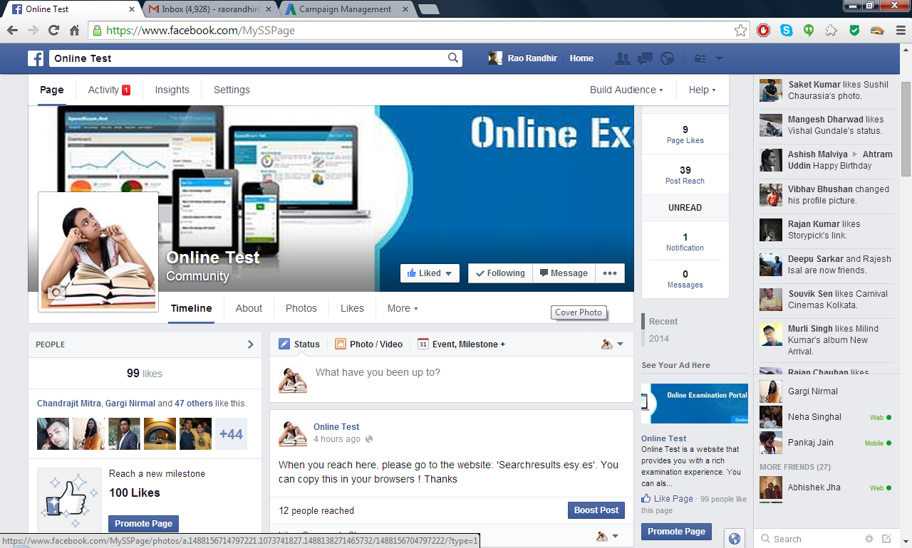
Figure 10: Facebook page: Online Test

Also, the URL that I use in this page is the title that I use for my HOME page. Thus it too helps in identifying the website linked to it wel. The consistency in this sense is maintained throughout.
https://www.facebook.com/MySSPage.
3.5 Analytics: Google Analytics to measure performance

Google Analytics is used to measure as to how the traffic of the website is being increased through the use of the above methodologies through 3.1 to 3.4. It measures the ‘Bounce Rate’, total page views etc. For this experiment, I have designed an event that if someone clicks on the facebook link on any of the web pages of my website, then only it would be analogous to having achieved a business or made profit else the user ‘Bounced’ without doing anything. I included the Google Analytics code in my website’s source code which is shown as highlighted in yellow below. The snapshot of Google Analytics dashboard is shown in figure 11.

<!DOCTYPE html>
<html lang="en">
<head>
<meta http-equiv="content-type" content="text/html; charset=utf-8" />
<title>My SS Page</title>
<base href="{{base_url}}" />
<meta name="viewport" content="width=1000" />
<meta name="description" content="This is SEO page for my SS project.
Page for my MBA project" />
<meta name="keywords" content="My SS page,SS project,My SS project,mba projects,2013-15 SS,MBA projects,SEO page for my MBA project" />

<link href="css/bootstrap.min.css" rel="stylesheet" type="text/css" />
<link href="css/bootstrap-responsive.min.css" rel="stylesheet" type="text/css" />
<script src="js/jquery-1.8.3.min.js" type="text/javascript"></script>
<script src="js/bootstrap.min.js" type="text/javascript"></script>
<script src="js/main.js" type="text/javascript"></script>
<meta name="google-site-verification" content="<script> (function(i,s,o,g,r,a,m){i['GoogleAnalyticsObject']=r;i[r]=i[r]||function(){ (i[r].q=i[r].q||[]).push(arguments)},i[r].l=1*new Date();a=s.createElement(o), m=s.getElementsByTagName(o)[0];a.async=1;a.src=g;m.parentNode.insertBefore(a,m) })(window,document,'script','//www.google-analytics.com/analytics.js','ga'); ga('create', 'UA-56081096-1', 'auto'); ga('send', 'pageview'); </script>" />
<style type="text/css">
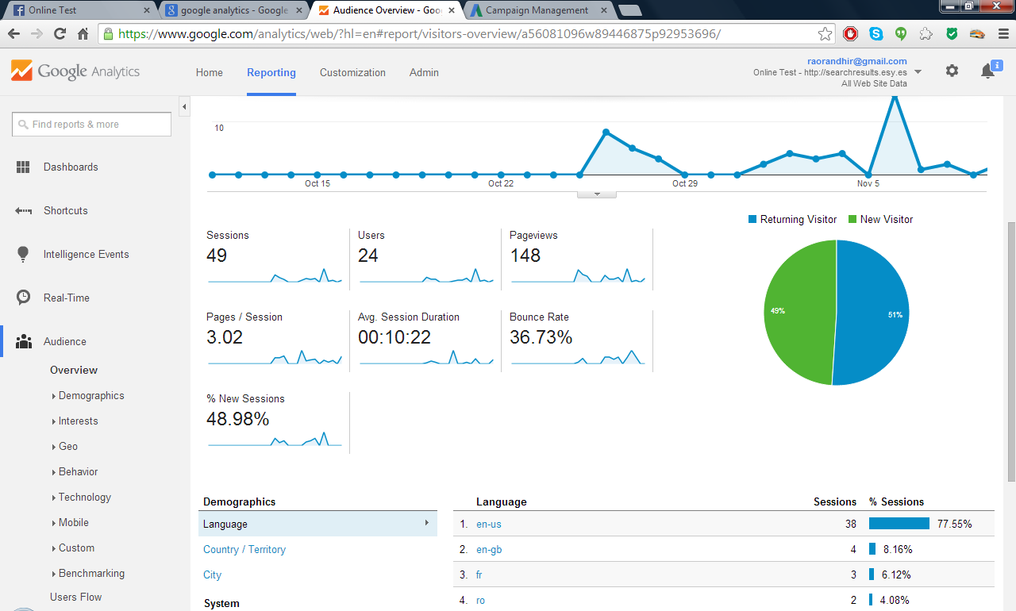
Figure 11: Google Analytics dashboard

4. Results

4.1 Analysis

The results that were obtained could be shown through the figures presented previously. For Ad words, the various keywords were studied to see as to how many impressions did they give that is, how many times did they show up in search results, how many times the ads were clicked( measured through the click through rate for each keyword). These represented the proximity of various keywords to the content and context of the website. Further, Google Analytics tool was used to measure as to how many people clicked on the facebook link provided on the web pages of the website. This was synonymous to earned business or the goal that we finally wanted to achieve through our offerings via the website. The various results are as below:

Ad Words:

Keyword Impressions Clicks CTR Avg Position

“My SS Page” 22 9 40.91% 1.0
“[My SS Project] 17 8 47.06% 1.4
[SS Project] 34 3 8.82% 1.3
SS page 4 101 3.96% 2.3

Google Analytics:

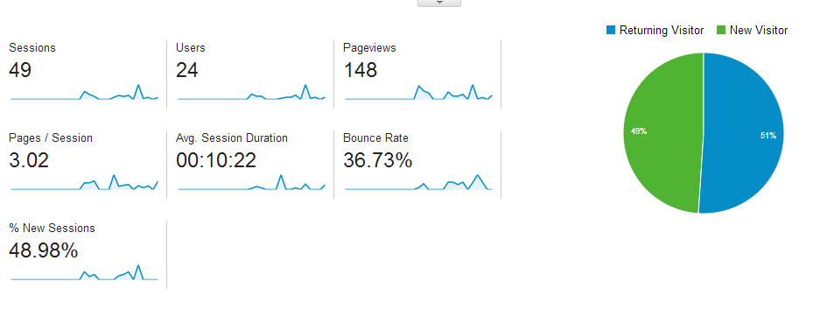

4.2 Interpretation of results

For Ad Words:

“My SS Page”: It is a phrase type match keyword. It is very specific to my project and has contributed in showing up of my ad in search results 22 times in the last month. It has been clicked 9 times in that. The relative position of 1.0 indicates that this particular keyword has made the ad appear above any other add with this relevance on Google Page (first page).

[My SS Project] and [SS Project] are exact match type keywords and have made the Ad show 34 and 17 times respectively. They show the Ad only when exact keyword is typed in search boxes. The Ad won’t show up if the exact letters with mentioned case are not typed. They have been clicked 8 and 3 times respectively. There positions are among top only, being 1.3 and 1.4 respectively.

SS page is a broad match keyword and that is the reason it shows the Ad most number of times (101 times). However, the click rate is very less (only 3 times). This shows that people have not found the page content appropriate to their needs 98 times and thus, have not clicked the Ad.

For Google Analytics:

It shows that a total of 24 users have viewed the page 149 times in total. Also, the bounce rate of 36.73% shows that 36.73% of the times the viewers have not clicked on the facebook link present on any of the pages of the website (this is the goal that I have set for my experiment’s purpose).

More interpretation of results:

Referring figures 8 and 9, we can infer that an Impression count of 174 indicates that your Ad has appeared this many times to the various users searching for combination of one or more keywords taken above. This indicates the reach or marketing of your website through your Ad campaign. A click count of 24 suggests that 24 times the Ad has been clicked to reach your website. As I have created a PPC type Ad campaign, the clicks have resulted in a cost of Rs 120.26 for me. Now my event of converting into sales is click on the facebook link on my website. Suppose that each click of that link fetches me Re 10, and with a bounce rate of 37% only (.63*24) are the total facebook clicks. Thus the total sales is: Rs (.63*24*10) = Rs 151. Thus my ROI on investing in Google Ad campaign is ((151-120)/120)*100 = 25.83% at the moment!

Also, the Search Engine Marketing of the website led to showing up of the website on the first page in the Google Organic Search results also if searched with the keyword ‘mysspage’ which is the title of the HOME page of the website as shown in the snapshot below. If further optimized and advertised with more generic keywords, it will improve for sure for other keywords too!

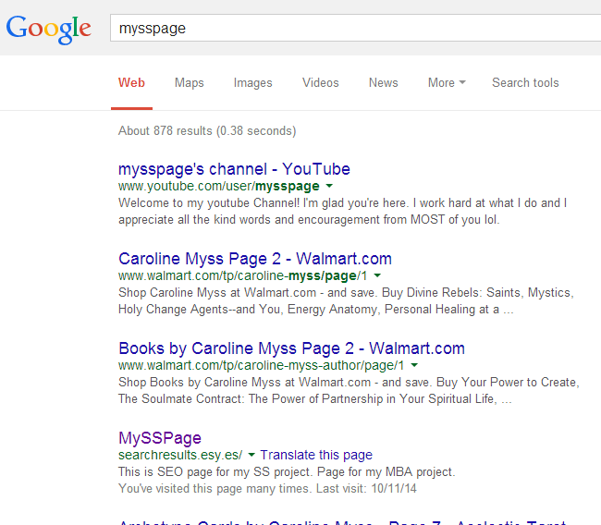

5. Limitations

Limitations were those of funds and time.

6. Conclusion

6.1 Conclusion

The advent of ‘Digital Marketing’ is an important addition to the traditional Marketing techniques. The intensive use of internet and social media has paved ways to advertise your offerings to a wide horizon of customer base worldwide. It also opens up numerous, attractive and interesting career opportunities to students.

Through this study, I learnt the end to end methodology of using Digital Marketing techniques at the basic level. Starting from Literature Review of various scholarly articles on this topic and understanding the theoretical aspects of the various topics well, I tried to gain significant hands on experience through the development of website, optimizing its code for Organic Search rank upgrades, creating Ad Word campaigns to market it well to get good ranks in the search results, various insights into keyword research and usage of Google Analytics and Social Media Platform like facebook to gain more market recognition quickly!

6.2 Scope for further study

I intend to further work on this project to:
- Develop the website well with more optimized and relevant content.
- Further optimize the code for Organic Search.
- Enhance and Expand the Ad Word campaign to include more generic keywords to reach more viewers in real time.
- More insights in the usage of Social Media Marketing Techniques , exploring Google Analytics platform in depth along with other Social Media Analytics techniques.

